Other
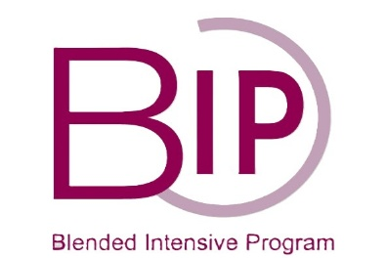

ERASMUS +
APPLICATION FORM

STUDENT PERSONAL DETAILS
Name(s)
Surname
Date of birth, age
Sex | ◻ Male ◻ Female
Mobile
E-mail address

HOME / SENDING INSTITUTION
Erasmus Coordinator
Telephone(s)
E-mail address
Professor in main field of study:
E-mail address

 | EDUCATION & QUALIFICATIONS
Academic level |  | Bachelor  Master
Year of study |  | ◻ 1st ◻ 2nd ◻ 3rd ◻ 4th
Main instrument

LANGUAGE SKILLS
Mother tongue:
Please indicate your language skills other than mother tongue:
1) Language________________ Fluent ◻ Good ◻ Moderate ◻ Limited ◻ None ◻
2) Language________________ Fluent ◻ Good ◻ Moderate ◻ Limited ◻ None ◻
3) Language________________ Fluent ◻ Good ◻ Moderate ◻ Limited ◻ None ◻

COMPUTER SKILLS
Basic ◻ | Intermediate ◻ | Advanced ◻

AUDITION
Link of a video recording:
I have included a certified* recording of my audition repertoire Yes □ No □
List of pieces performed on your recording:

*Please let the teacher of your main subject sign the recording to certify that the recording is your own performance.

EMERGENCY CONTACT
PERSON (relatives, family, close friend) TO BE NOTIFIED IN CASE OF EMERGENCY:
Name, surname
Home address
Telephone(s)
E-mail address

ACADEMIC REFERENCES
Name, surname
Department/programme
Telephone
E-mail

I CERTIFY THAT THE INFORMATION GIVEN IS CORRECT
Student

Signature

Date:________________________________

Please note!
Application must be made through the International Exchange Coordinator in the home institution

